GOVERNMENT HIGH SCHOOL – Jayanagar 9th Block
MULTIPLE CHOICE QUESTIONS
CHAPTER: Circles UNIT: Tangent to a circle
STANDARD: 10 DATE:
STUDENT NAME: MARKS OBTAINED:
1) How many tangents can be drawn to a circle at any point of it?
A) 1 B) 2 C) 3 D) None of the above
Answer: ___________
2) How many tangents can a circle have?
A) two B) infinitely many C) one D) many
Answer: _________________
3) A line which intersect a circle at two distinct point is called:
A) tangent B) secant C) point D) parallel
Answer: ______________
4) The number of parallel tangents a circle can have at the ends of a diameter is:
A) 1 B) 2 C) 0 D) 3
Answer: _____________
5) A line which intersect a circle at only one point is called:
A) tangent B) secant C) point D) parallel
Answer: ______________
6) Two tangents drawn at the ends of a diameter of a circle, if extended, will be at an angle
of:
A) 30⁰ B) 120⁰ C) 0⁰ D) 90⁰
Answer: __________
7) The distance between the point of contacts of two parallel tangents to a given circle of
radius 6 cm is:
A) 6 cm B) 12 cm C) 9 cm D) 18 cm
Answer: __________
8) Two circles of radii 5 cm and 3 cm touch each other internally. The distance between their
centre is:
A) 5 cm B) 3cm C) 2 cm D) 8 cm
Answer: _____________
9) If the angle between two radii of a circle is 130⁰, the angle between the tangents at the
end of the radii is:
A) 90⁰ B) 50⁰ C) 70⁰ D) 40⁰
Answer: ___________
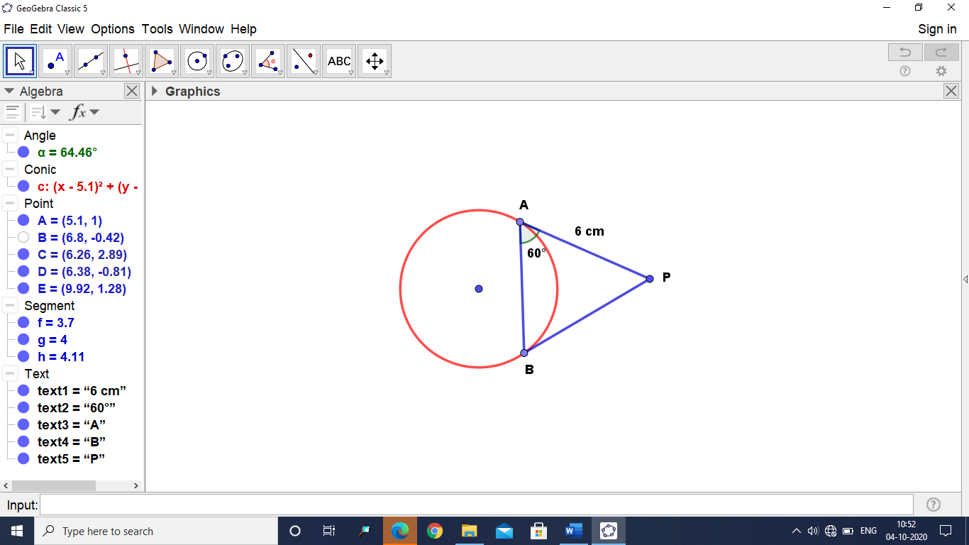
10) In the following figure, find the length of the chord AB, if PA = 6 cm and PAB = 60⁰
A) 2 cm B) 4 cm
C) 6 cm D) 5 cm
Answer: _______________
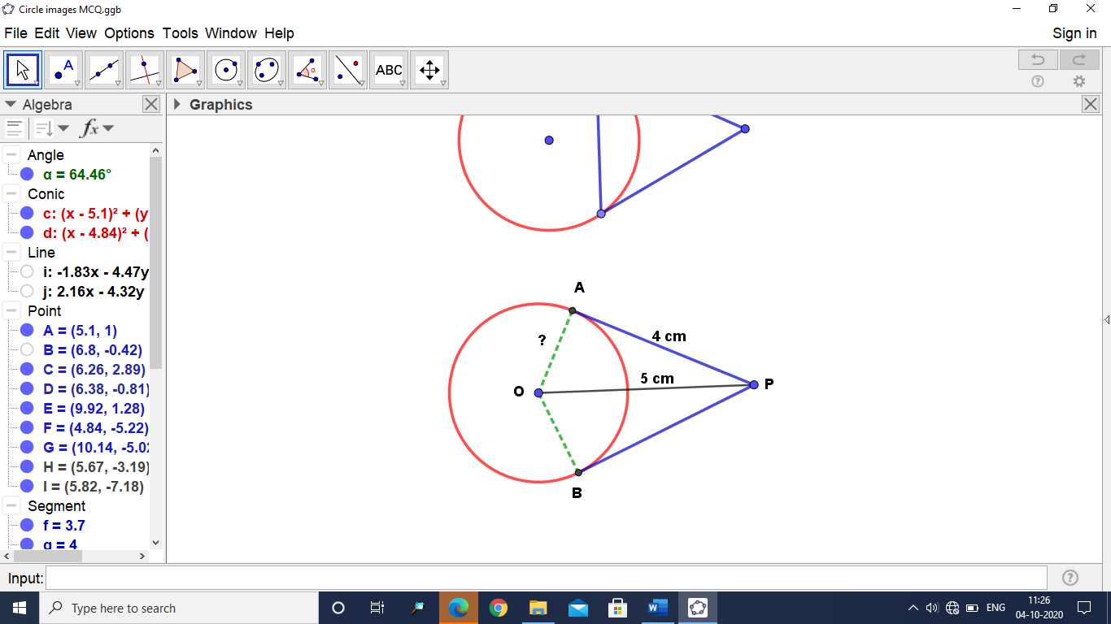
11) PA is a tangent to a circle from a point P with centre O. Find the radius OA, if PA = 4 cm and OP = 5 cm.
A) 2 cm B) 3 cm
C) 1.5 cm D) none
Answer: _____________
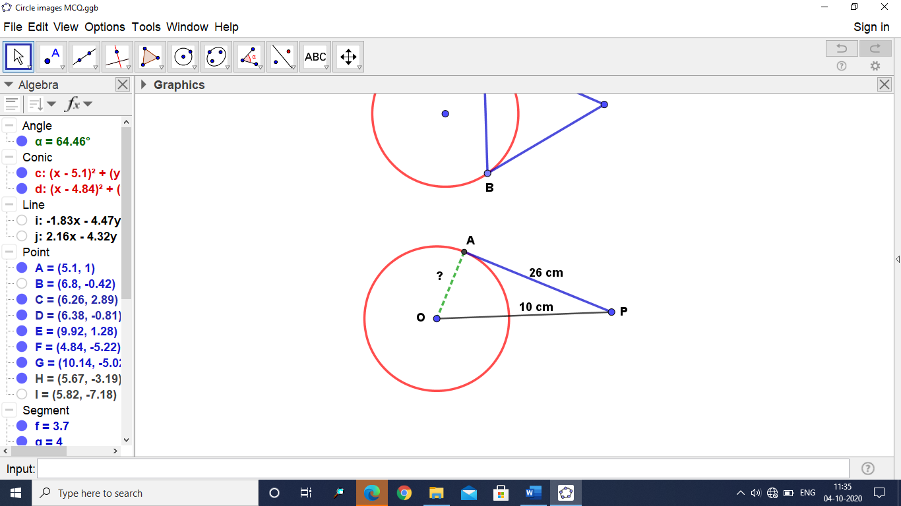
12) If the length of the tangent from a point A at a distance
of 26 cm from the centre of the circle is 10 cm, then the
radius the circle is:
A) 22 cm B) 24 cm
C) 21 cm D) 23 cm
Answer: ____________
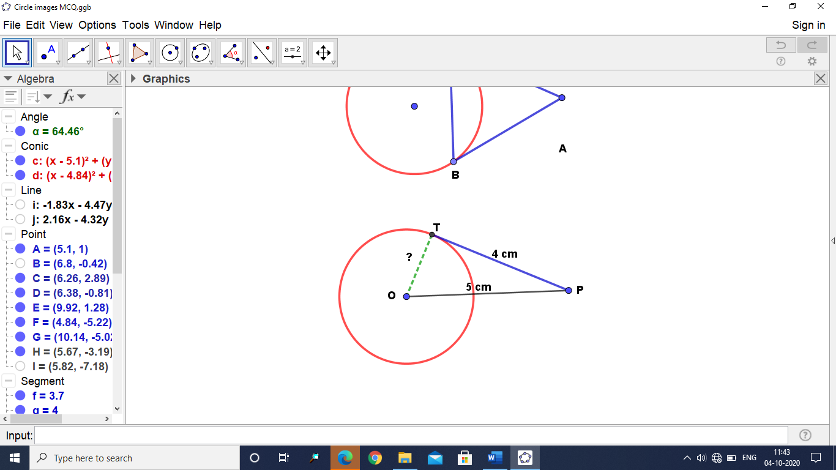
13) A tangent PT from an outside point P is drawn to a circle with centre O. If PT = 4 cm and P lies 5 cm away from the centre, then the radius of the circle is:
A) 3 cm B) 4.5 cm
C) 4 cm D) cm
Answer: ____________
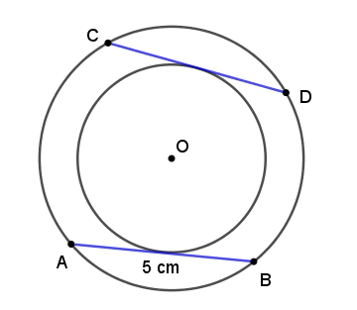
14) In the following figure, find CD if AB = 5 cm
A) 5 cm B) 4 cm
C) 3 cm D) 2 cm
Answer: ____________

15) Three circles are drawn with the vertices of a triangle as centres such that each circle
touches the other two. If the sides of the triangle are 2 cm, 3 cm and 4 cm, find the
diameter of the smallest circle.
A) 1 cm B) 3 cm C) 5 cm D) 4 cm
Answer: ____________
Teacher Signature:
___________________________________________________________________________

