GOVERNMENT HIGH SCHOOL
JAYANAGAR

FORMATIVE ASSESSMENT - ACTIVITY -

SUBJECT:
CHAPTER:
UNIT:
DATE:
STUDENT NAME:
CLASS AND SECTION:
MARKS OBTAINED:
TEACHER SIGNATURE:

GOVERNMENT HIGH SCHOOL, JAYANAGAR
CHAPTER: TRIANGLES UNIT: PYTHAGORAS THEOREM
CLASS: 10 SUBJECT: MATHEMATICS
FORMATIVE ASSESSMENT: 1 ACTIVITY: 2
STUDENT NAME: MARKS OBTAINED:
Activity
Objective: To verify the Pythagoras Theorem by the method of paper folding, cutting and pasting.
Materials Required: White sheets of paper, tracing paper, a pair of scissors, glue stick, geometry box, etc.
Procedure:
1. On a white sheet of paper, draw a right triangle ABC, right angled at B and AB = x, BC = y and AC = z.
AB = x = 6 cm, BC = y = 8 cm and AC = z = 10 cm.

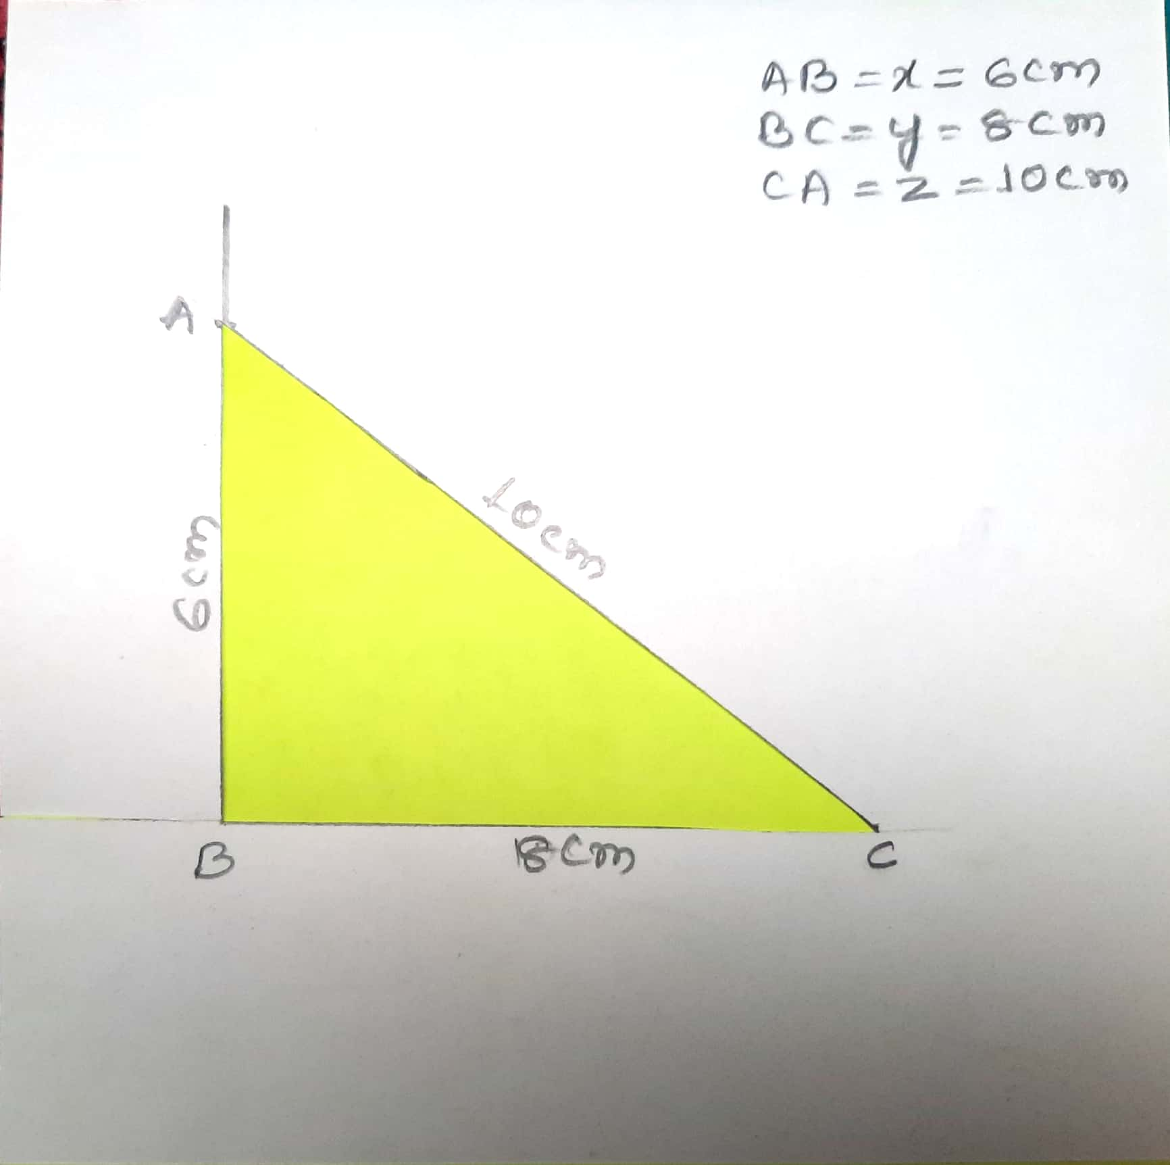

2. Using tracing paper, trace the triangle ABC and make 4 replicas of it. Shade each triangle using different color. Cut out each triangle.
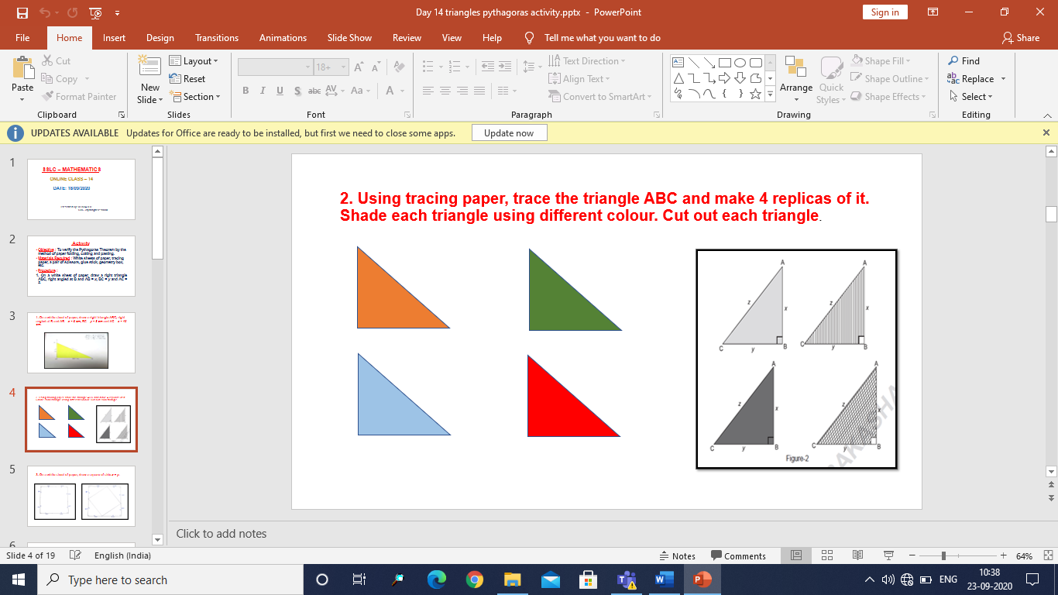

3. On a white sheet of paper, draw a square of side x + y.

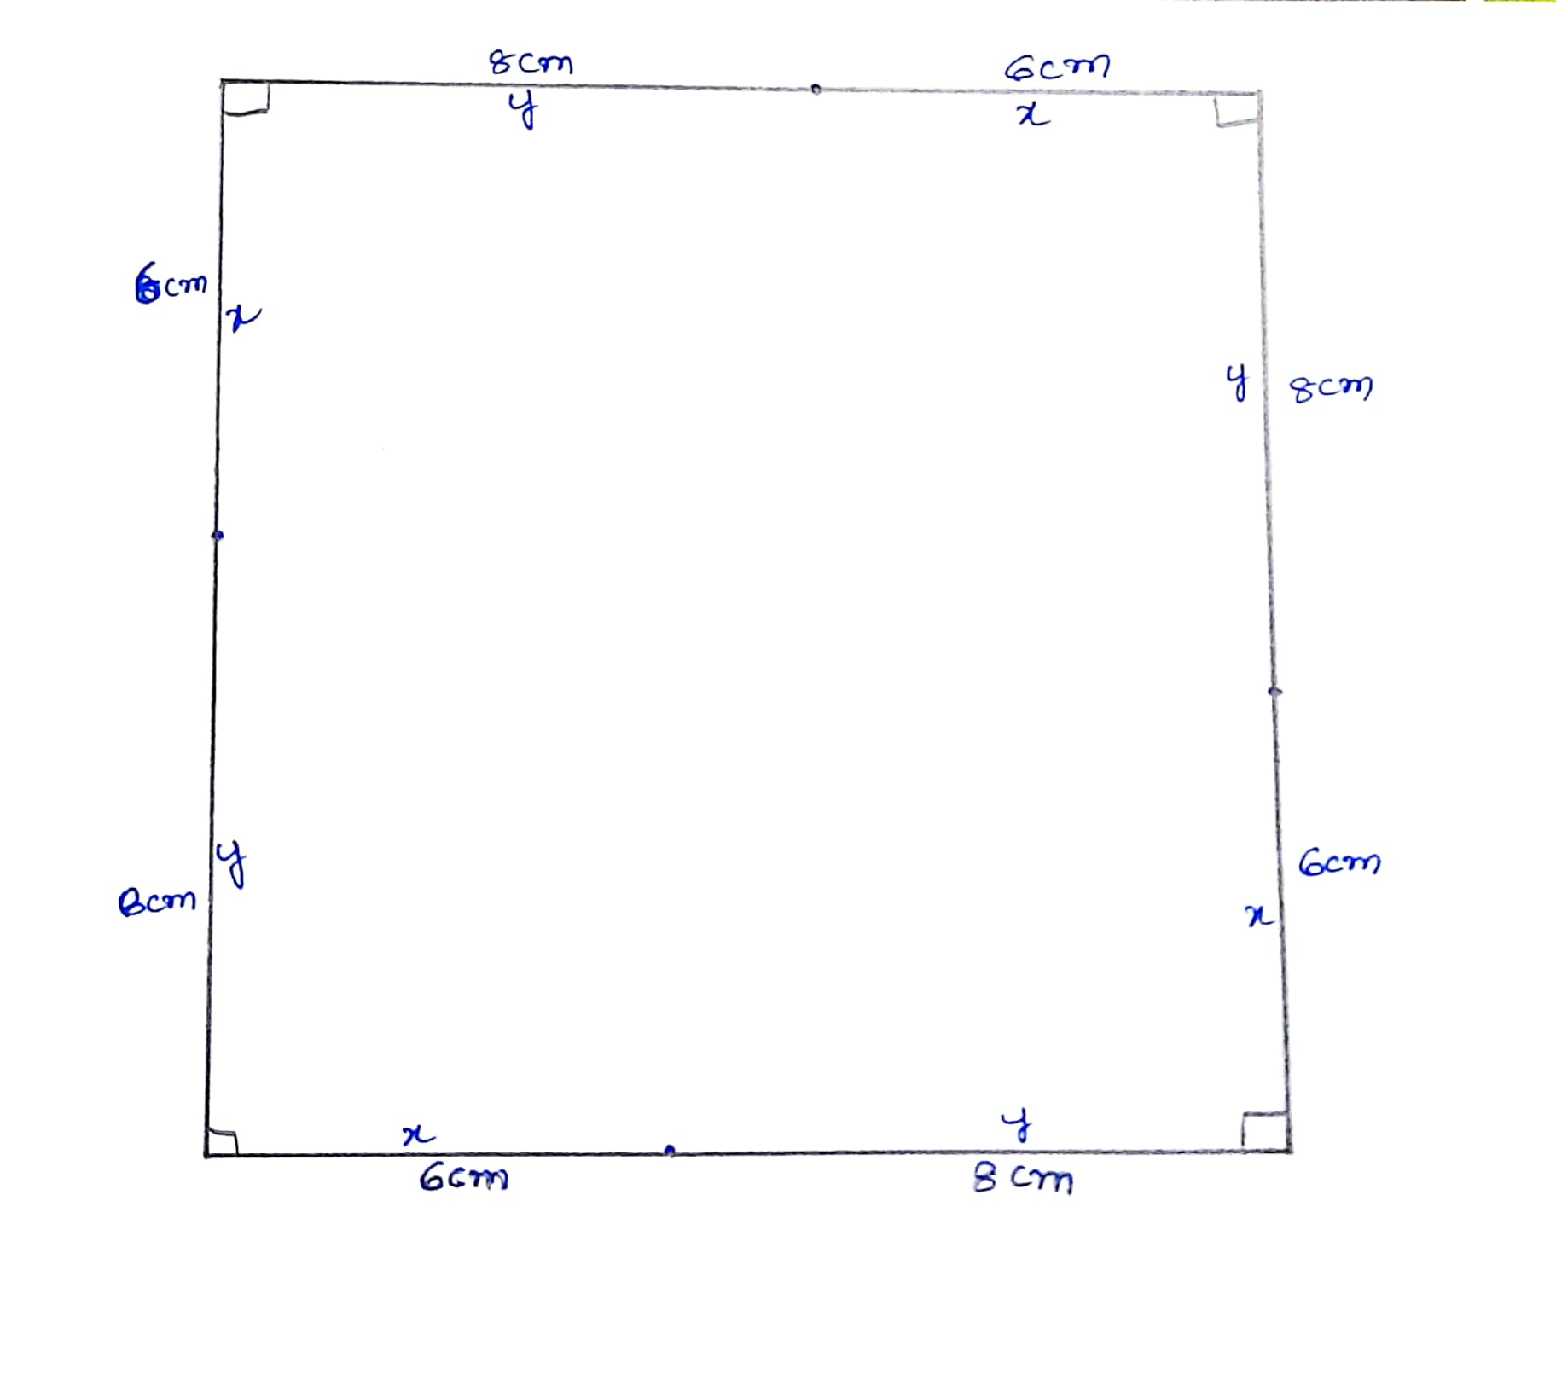

4. Paste the 4 right triangles and the square cut out obtained as shown in the figure.
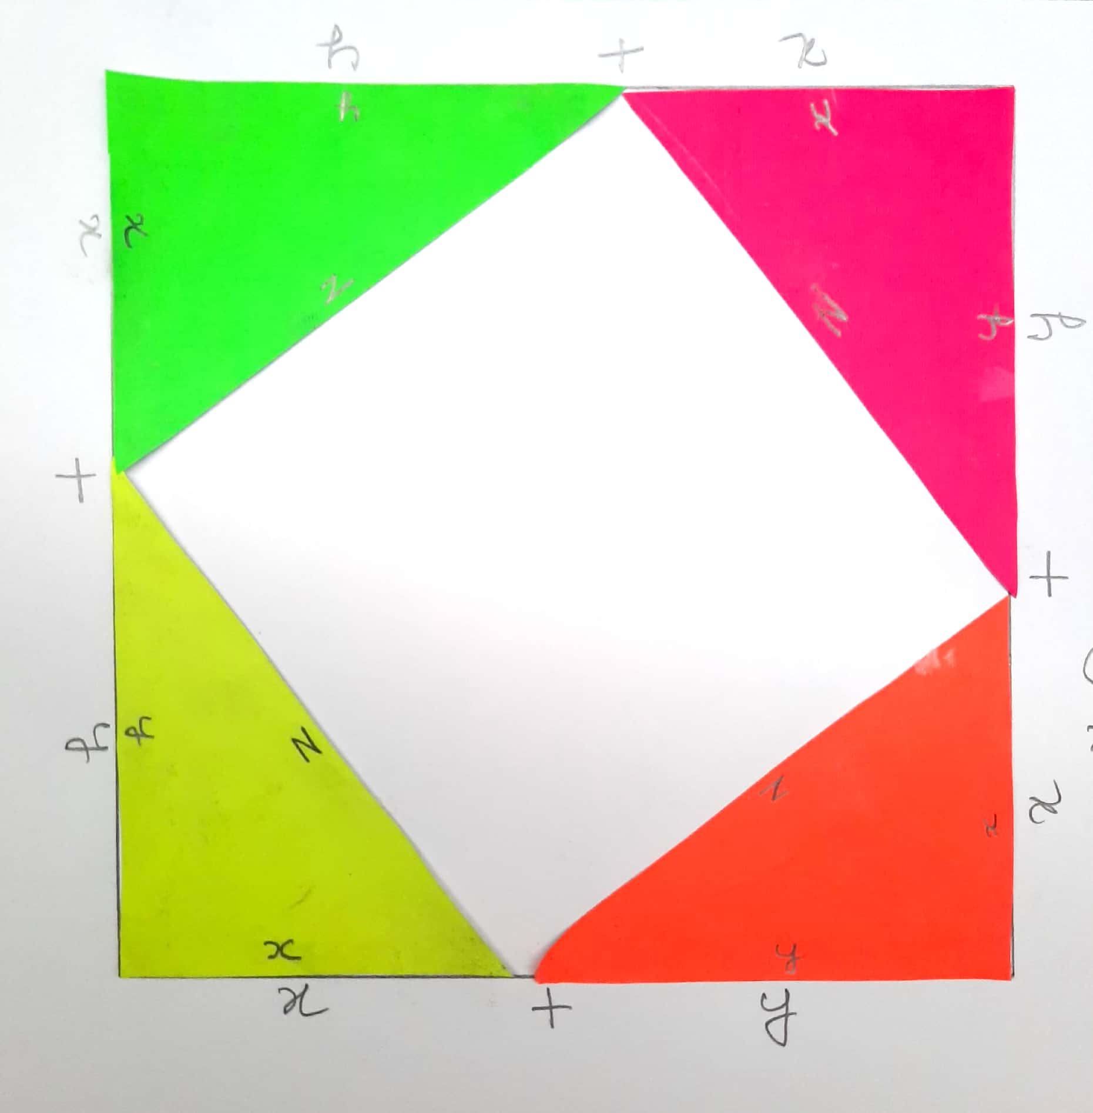

Observations:
1. In the figure, we see that it is a square of ABCD = side (x + y).
So, area of ABCD square = (x + y)2 ……… (1)
2. Also,
area of square = area of the square of side z + 4 × area of ΔABC
= z2 + 4 (1/2 × xy)
= z2 + 2xy …….(2)
3. From 1 and 2 above, (x + y)2 = z2 + 2xy
⇒ x2 + y2 + 2xy = z2 + 2xy
⇒ x2 + y2 = z2

Conclusion

From the above activity, it is verified that
“In a right triangle the square of the hypotenuse is equal to the sum of the squares of other two sides”.

Pythagoras Theorem is verified

Do Yourself:
Draw two different right triangles and verify the Pythagoras Theorem by Activity method in each case.
1) AB = a = 12 cm, BC = b = 5 cm and AC = c = 13 cm.
2) QR = a = 4 cm, PQ = b = 3 cm and PR = c = 5 cm.

